**Attributes**

|  |  |  |  |  |  |  |  |  |  |
| --- | --- | --- | --- | --- | --- | --- | --- | --- | --- |
| Pace | Shooting | Passing | Dribbling | Defending | Physicality | Goalkeeper | Preferred foot | Attacking work rate | Defending work rate |
| Acceleration | positioning | Vision | Agility | Interceptions | Jumping | Diving | Left | Low | Low |
| Sprint speed | finishing | crossing | Balance | Heading | Stamina | Reflexes | Right | Medium | Medium |
|  | Shot power | Pass free kick | Reactions | Marking | Strength | Handling |  | High | High |
|  | Long shots | Short | Ball control | Stand tackle | Aggression | Speed |  |  |  |
|  | Volleys | Long | Dribbling | Slide tackle |  | Kicking |  |  |  |
|  | Penalties | Curve | Composure |  |  | Positioning |  |  |  |

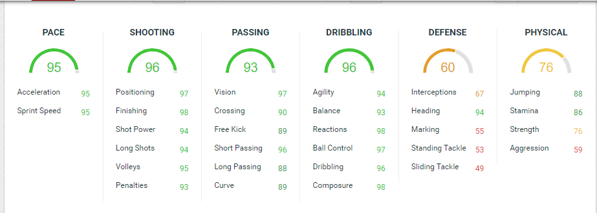

FIFA 19 Forum

<https://fifaforums.easports.com/en/discussion/428085/how-fifa19-stats-calculation-for-4th-year-project/p1>

**Team Types**

|  |  |  |  |  |  |  |
| --- | --- | --- | --- | --- | --- | --- |
| National | Bronze | Bronze – rare | Silver | Silver – rare | Gold | Gold – rare |
| Club | Bronze | Bronze – rare | Silver | Silver – rare | Gold | Gold – rare |
| League | Bronze | Bronze – rare | Silver | Silver – rare | Gold | Gold – rare |
| Icon | ---------------------- | ---------------------- | ---------------------- | ---------------------- | ---------------------- | ---------------------- |

Attributes extra points

Between: 0 – 25 = 0.25

Between: 25 – 50 = 0.50

Between: 50 – 75 = 0.75

Between: 75 – 100 = 1

14 attributes out of 27

**Attributes to be calculated**

|  |  |  |  |
| --- | --- | --- | --- |
| Position | Attacking attributes | Defending attributes | Goal keeping attributes |
| GK | ------------------------------------------------------------------------------------------------------------------------------------------------------------------------------------------------------------ | ------------------------------------------------------------------------------------------------------------------------------------------------------------------------------------------------------------------------ | Diving  Reflexes  Handling  Speed  Kicking  Positioning |
| RB | Acceleration  Sprint speed  Crossing  Short  Vision  Ball control  Composure | Interceptions  Heading  Marking  Stand tackle  Slide tackle  Strength  Aggression | ------------------------------------------------------------------------------------------------------------------------------------------------------------------------------------------------------------------------ |
| RWB | Acceleration  Sprint speed  Crossing  Short  Long  Vision  Ball control  Composure  Long shots | Interceptions  Marking  Stand tackle  Slide tackle  Strength | ------------------------------------------------------------------------------------------------------------------------------------------------------------------------------------------------------------------------ |
| CB | Short  Vision  Long  Composure  Reactions | Interceptions  Heading  Marking  Stand tackle  Slide tackle  Strength  Aggression  Jumping  Stamina | ------------------------------------------------------------------------------------------------------------------------------------------------------------------------------------------------------------------------ |
| LWB | Acceleration  Sprint speed  Crossing  Short  Long  Vision  Ball control  Composure  Long shots | Interceptions  Marking  Stand tackle  Slide tackle  Strength | ------------------------------------------------------------------------------------------------------------------------------------------------------------------------------------------------------------------------ |
| LB | Acceleration  Sprint speed  Crossing  Short  Vision  Ball control  Composure | Interceptions  Heading  Marking  Stand tackle  Slide tackle  Strength  Aggression | ------------------------------------------------------------------------------------------------------------------------------------------------------------------------------------------------------------------------ |
| CDM | Long  Vision  Ball control  Composure | Interceptions  Heading  Marking  Stand tackle  Slide tackle  Strength  Aggression  Jumping  Stamina | ------------------------------------------------------------------------------------------------------------------------------------------------------------------------------------------------------------------------ |
| CM | Short  Long  Vision  Ball control  Composure  Long shots  Curve  Reactions | Stand tackle  Slide tackle  Strength  Jumping  Stamina  Aggression | ------------------------------------------------------------------------------------------------------------------------------------------------------------------------------------------------------------------------ |
| CAM | vision  Agility  Finishing  Dribbling  Balance  Shot power  Pass free kick  Ball control  Composure  Acceleration  Sprint speed | Strength  Jumping  Stamina | ------------------------------------------------------------------------------------------------------------------------------------------------------------------------------------------------------------------------ |
| RF | Acceleration  positioning  Agility  Sprint speed  finishing  Balance  Shot power  Long shots  Ball control  Volleys  Dribbling  Penalties | Strength  Jumping | ------------------------------------------------------------------------------------------------------------------------------------------------------------------------------------------------------------------------ |
| CF | Acceleration  positioning  Agility  Sprint speed  finishing  Balance  Shot power  Long shots  Ball control  Volleys  Dribbling  Penalties | Strength  Jumping | ------------------------------------------------------------------------------------------------------------------------------------------------------------------------------------------------------------------------ |
| ST | Acceleration  positioning  Agility  Sprint speed  finishing  Balance  Shot power  Long shots  Ball control  Volleys  Dribbling  Penalties | Strength  Jumping | ------------------------------------------------------------------------------------------------------------------------------------------------------------------------------------------------------------------------ |
| LF | Acceleration  positioning  Agility  Sprint speed  finishing  Balance  Shot power  Long shots  Ball control  Volleys  Dribbling  Penalties | Strength  Jumping | ------------------------------------------------------------------------------------------------------------------------------------------------------------------------------------------------------------------------ |

<https://www.fifarosters.com/create-card>